**DAILY ONLINE ACTIVITIES SUMMARY**

|  |  |  |  |  |  |  |  |  |
| --- | --- | --- | --- | --- | --- | --- | --- | --- |
| **Date:** | **13/07/2020** | | | | | **Name:** | **Spoorthy Balaji** | |
| **Sem & Sec** | **6th & B** | | | | | **USN:** | **4al17cs098** | |
| **Online Test Summary** | | | | | | | | |
| **Subject** | | **CNSC IA Module 2** | | | | | | |
| **Max. Marks** | | **30** | | **Score** | | | **-** | |
| **Certification Course Summary** | | | | | | | | |
| **Course** | **Introduction to HTML5** | | | | | | | |
| **Certificate Provider** | | | **Coursera** | | **Duration** | | | **1month** |
| **Coding Challenges** | | | | | | | | |
| **Problem Statement: Python Program for Coin Change** | | | | | | | | |
| **Status: Solved** | | | | | | | | |
| **Uploaded the report in Github** | | | | | **yes** | | | |
| **If yes Repository name** | | | | | <https://github.com/spoorthybalaji/Daily_Status> | | | |
| **Uploaded the report in slack** | | | | | **yes** | | | |

**ONLINE COURSE**

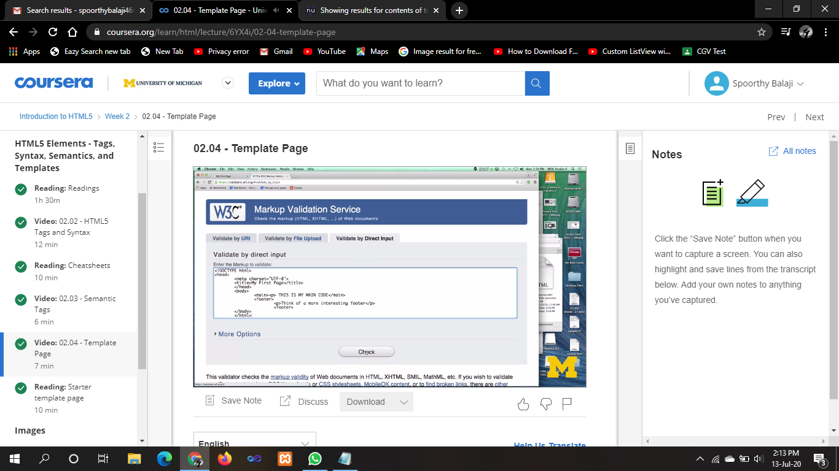

**ONLINE CODING**

**Python Program for Coin Change.**

def count(S, m, n):

table = [[0 for x in range(m)] for x in range(n+1)]

for i in range(m):

table[0][i] = 1

for i in range(1, n+1):

for j in range(m):

x = table[i - S[j]][j] if i-S[j] >= 0 else 0

y = table[i][j-1] if j >= 1 else 0

table[i][j] = x + y

return table[n][m-1]

arr = [1, 3, 2, 4]

m = len(arr)

n = 5

print("Number of coins:",count(arr, m, n))

